Talking Points

- Caregivers in long term care facilities serve their communities by caring for their most vulnerable citizens in a safe and supportive environment.

- A career in long term care offers professional growth, is invaluably rewarding and provides a tremendous sense of purpose.

- Being a caregiver at a long term care facility goes far beyond your job description – you become a friend and a family member to each resident.

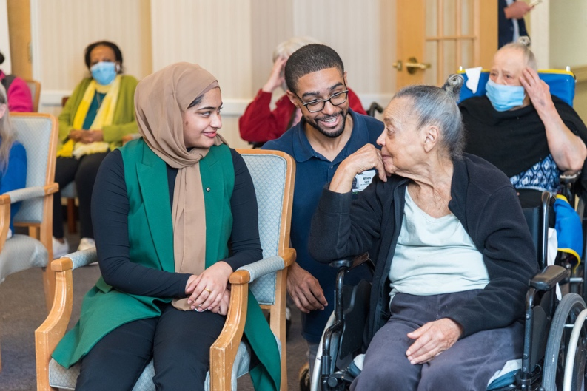
- Working in a long term care facility means working as a team to accomplish a common goal – ensuring residents are receiving the highest level of care possible.

- Long term care facilities are only as strong as their caregivers. They are the backbone of every facility.

- Facilities value and appreciate the selfless work their caregivers do every day for their residents and ensure staff members feel supported.

- Working in a long term care facility means serving a special population – our most vulnerable population. Every resident is someone’s parent, grandparent, aunt, uncle or close friend.

- Families and friends of residents trust our caregivers to keep their loved ones healthy and safe day in and day out. Their work is incredibly meaningful and important.

- Long term care is a vital part of the health care system. A career in a long term care facility is a great steppingstone for individuals who want to get their foot in the door in the health care sector.

- The average age of a long term care resident is 85 years old, and the vast majority have underlying health conditions.
- Residents in long term care facilities require specialized, customized care to meet their unique health care needs. When you work in long term care, you are learning life-sustaining skills.

- There are countless opportunities for upward mobility working in long term care facilities. From the first day on the job, you are on an immediate path toward a long and fulfilling professional career.

- Aging is inevitable, and we are expected to see an unprecedented growth in our senior population over the next three decades. We need dedicated caregivers now more than ever.

###

