Q&A

Q: Why should someone work in the long term care industry?
A: A career in long term care offers professional growth, is invaluably rewarding and provides a tremendous sense of purpose by caring for the nation’s most vulnerable population. The growth opportunities, coupled with the day-to-day fulfilment working with incredible individuals united in a common purpose with a passion to serve, make a job in long term care unlike any other in the job market.

Q: What is it like working in a long term care facility?
A: Every nursing home, assisted living community or other long term care provider is a family with everyone working together for the health and wellbeing of their residents. Every staff member is valued, and the facilities make it a point to make every worker feel appreciated. Caregivers give each resident specialized, one-on-one care, while also acting as their constant companion, often finding a best friend in a resident.

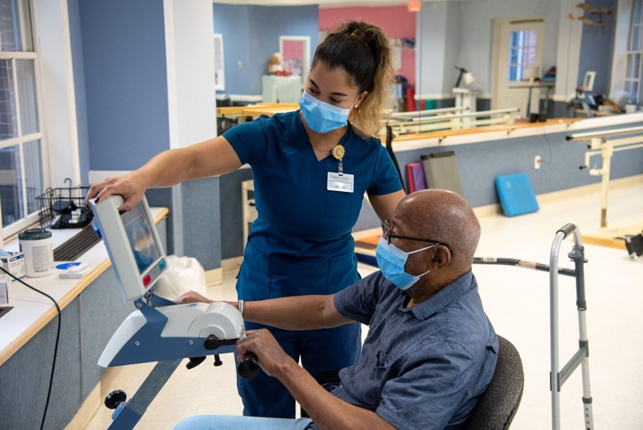
Q: What kind of people do caregivers in a long term care facility serve?
A: Long term care providers serve a very special population, our elderly. Every resident is someone’s mother, father, grandparent, aunt, uncle or friend. The average age of a long term care resident is 85 years old, so each one has lived a long life, filled with incredible stories and life lessons. The relationships and emotional connections made between caregivers and residents are extremely special.

Q: Is working in long term care part of the health care sector?
A: Long term care is a vital component of our health care system. Caregivers are medical professionals who ensure that our seniors live their healthiest and happiest lives. And the skills learned and fostered in a long term care setting transfer well to other health care settings.

Q: What sets a career in long term care apart from other jobs in health care]?
A: There is a familial aspect to long term care that you won’t find anywhere else. Caregivers aren’t only a nurse or a physical therapist. Relationships with residents can develop over years – something that is unique to the long term care setting. You will have the opportunity to tailor your care to each resident’s preference, which is valued and appreciated by those in your care.

Q: Are there growth opportunities working in long term care facilities?
A: Yes. Once you enter the long term care sector, you are put on an immediate career path with tremendous opportunity for upward mobility. Today’s certified nursing assistant (CNA) is tomorrow’s registered nurse (RN). The opportunity for growth is one reason why starting your career in long term care is a great steppingstone to get into the health care field.

Q: What kind of skills do caregivers in facilities learn?
A: Each resident has different health care needs. One resident may have memory issues, while another may need physical, occupational or speech therapy – no two residents are the same. Working in long term care gives you the opportunity to learn life-sustaining skills that protect the health and wellbeing of every resident.

Q: Is there a demand for caregivers?
A: Aging is inevitable, and we expect to see unprecedented growth in our senior population over the next three decades. That means the demand for more caregivers has never been greater. We must ensure our current and future elderly population have the caregivers they need to live their golden years with dignity.

###

