

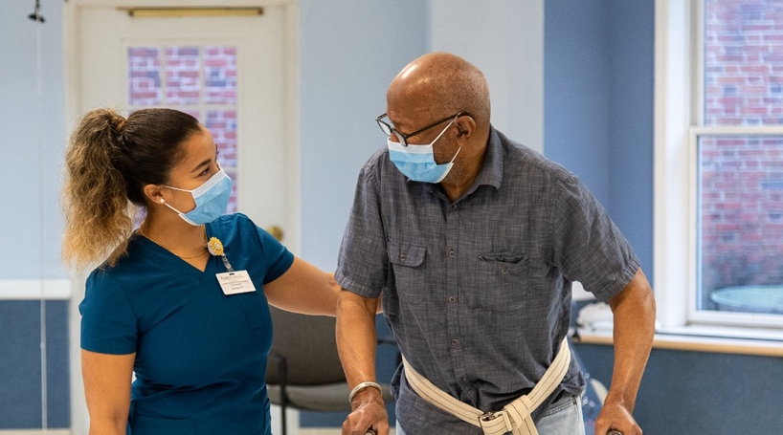

**A LONG TERM CALLING**

**Who We Are**

[FACILITY NAME] is a single family, made up of heroic caregivers united in a common purpose and a relentless passion to serve our nation’s most vulnerable population.

Our residents are a special group of individuals with stories to share – some have lived through world wars, and others have watched the first man walk on the moon.

**Why Work in Long Term Care?**

**Build Lasting Bonds**

You’re more than just your job title. You become a friend and family member to the residents in your care.

Our staff are the backbone of every long term care facility. We value and cherish every one of our employees.

**Start Your Health Care Career**

We are medical professionals. Working in long term care is working in health care.

You will learn invaluable life- sustaining skills working

at [FACILITY].

**Upward Mobility from Day One**

Today’s certified nurse assistant is tomorrow’s registered nurse.

Once you enter the long term care workforce you are on a path toward lasting and meaningful professional growth.

**Join Our Team**

We currently have [NUMBER] open positions.

We are offering wages ranging from [FACILITY-SPECIFIC PAY].

We offer competitive benefits, such as [FACILITY-SPECIFIC BENEFITS] for our staff.

We need caregivers more than ever at [FACILITY NAME]. Join us in serving our vulnerable population and start your meaningful career in health care today.

**CAREERSINCARING.ORG**